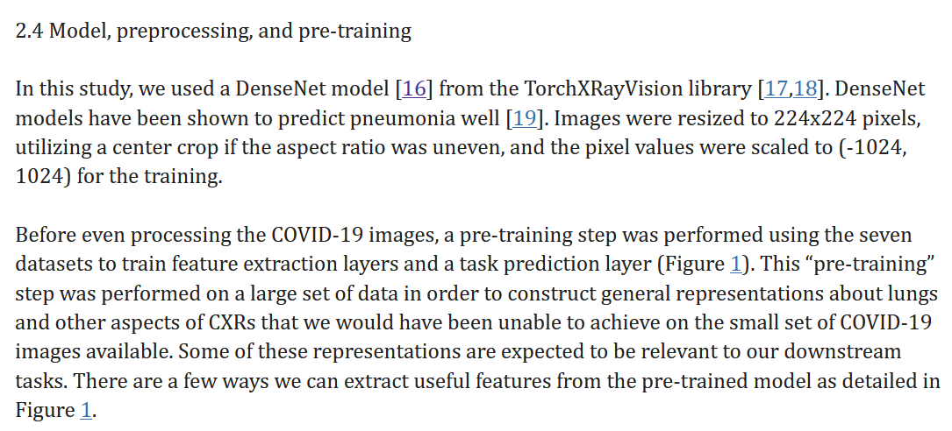

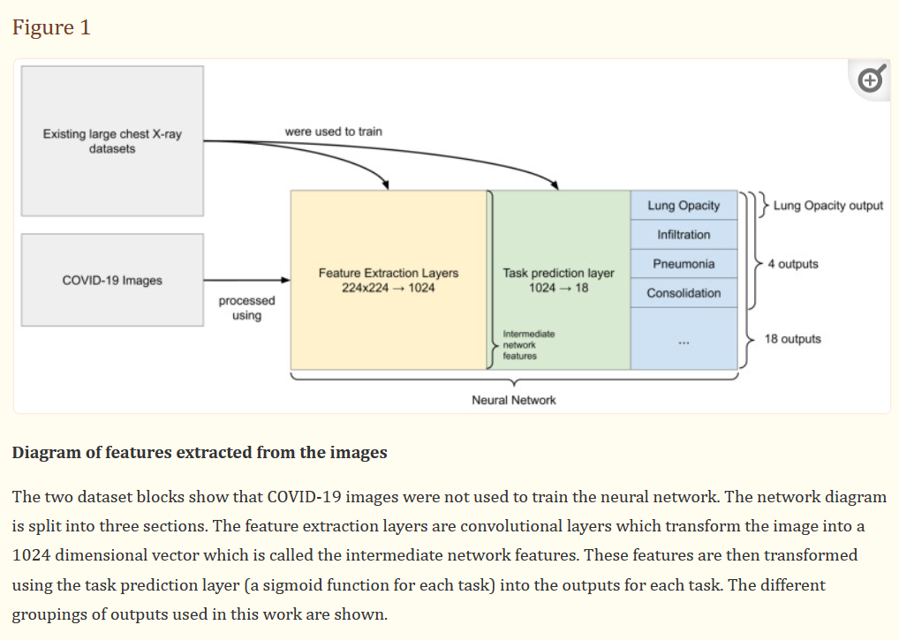

Preprocessing:  
<https://www.ncbi.nlm.nih.gov/pmc/articles/PMC8982897/>   
DenseNets:

<https://www.ncbi.nlm.nih.gov/pmc/articles/PMC7451075/#REF16>

<https://github.com/liuzhuang13/DenseNet>

Covid Net:   
<https://github.com/lindawangg/COVID-Net>

Exploring Feature Extraction with CNNs: <https://towardsdatascience.com/exploring-feature-extraction-with-cnns-345125cefc9a>